TAM 554-Homework #5 Name_____________________

Due October 27, 2021

1. The beam AB shown below is bent into a circular arc AC in a plane strain deformation. The motion is described by the mapping



where is a function of Y, ,  is the deformed configuration and (X,Y) is the undeformed configuration.

1. Determine the deformation gradient and the stretch tensor.

(2) Determine f(Y) so the motion is incompressible.

(3) What is the Green strain for the beam.

(4) The ten sile side of the beam has a true stress  where is a constant and is a unit vector tangential to the beam center line. What is the nominal stress (Second PK stress) on the tensile side of the beam?

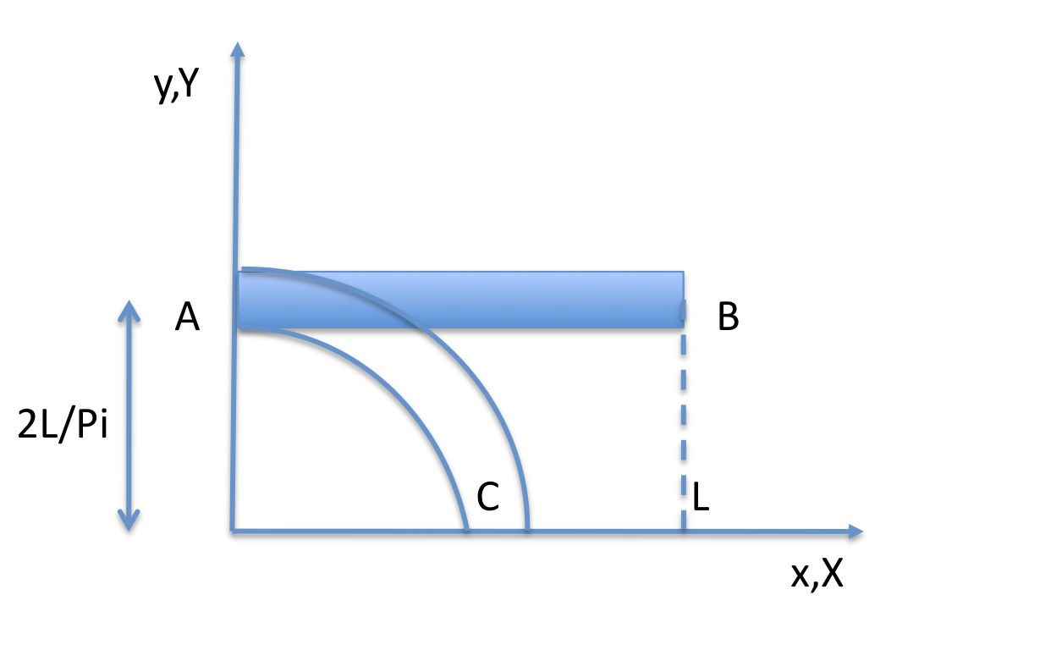

2. We consider the simple shear case under large deformations.

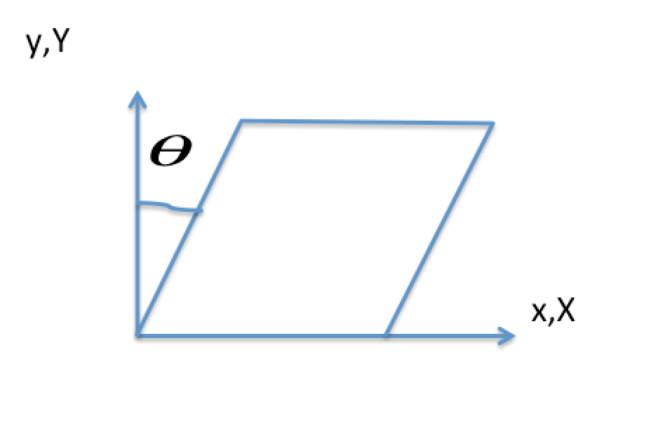

Elastic Case- Using the The Green Naghdi Rate of Cauchy stress , determine the shear stress-shear strain curve. Show all your equations step by step. Make a plot of normalized shear versus shear strain. Show that the shear stress is monotonically increasing function of shear strain and we do not expect oscillatory response in this case.